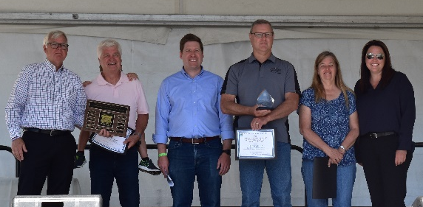
Please use one form for each volunteer nominated in each category.
Remember to spell out acronyms and to give specific examples of the volunteer’s work and the importance to clients, the county, and/or community. A volunteer may be honored for ongoing or past service to a program, or for work on a one-time project. Anyone may submit a nomination, and volunteers may be nominated for more than one category.
See the 2022 Volunteer Award Information Sheet for details and category descriptions.

- Name of Nominee: Click here to enter text.
Address: Click here to enter text. City: Click here to enter text.
Phone: Click here to enter text. E-Mail: Click here to enter text.

- Nominating Department or Program: Click here to enter text.
Name of Person Responsible for Nomination: Click here to enter text.
Phone: Click here to enter text. E-Mail Address: Click here to enter text.
- Nomination Type: You may nominate a volunteer for more than one award category, but must use a separate nomination form for each nomination (see the 2021 Volunteer Award Information Sheet for more info and descriptions). Marion County Board of Commissioners recognizes volunteers in five award categories (check one):

☐ Youth Volunteer – under the  age of 24 | ☐ Commissioner Mary Pearmine Outstanding Volunteer Group Award
☐ Division/Program Award | ☐ Judge Rex Hartley Volunteer of the Year Award
☐ Advisory Board Volunteer Award

- Using specific examples, describe the nominee or group volunteer activities and any skills used: Click here to enter text.
- Again, using specific examples, describe the impact of the nominee or group activities on clients, departments, county, and/or community. Describe who benefits from the volunteer work: Click here to enter text.
- In a few words, describe what makes this volunteer or group a candidate for special recognition: Click here to enter text.

