

TEMPORARY RESTAURANT APPLICATION
THIS LICENSE CAN ONLY BE ISSUED IN CONJUNCTION WITH A TEMPORARY COMMUNITY EVENT
AT LEAST ONE PERSON WITH A FOOD HANDLER CARD MUST BE PRESENT AT ALL TIMES

Single Event License (up to 30 days) |  | Seasonal License (up to 90 days | see back page)
Benevolent → Non-Profit Tax ID#: ________________________  For profit Out of County Mobile Unit: ________________  Contiguous to facility (operating directly outside your restaurant) |  | Intermittent License (up to 30 days | see back page)
 |  | Operational Review: included on file

Event Name: | Dates of Event:
Event Address: | Hours of Operation:
Food Booth Name: | Email:
Owner or Person in Charge of Booth: | Phone:

Mailing Address:
Event Organizer: | Organizer’s Phone:

All food must be prepared at the event or in a facility approved by the Health Department or the Department of Agriculture.
Where is food being purchased? |  | Water Source: | Public (city)  Private (local well)

Where will dishwashing take place?

Name & Address of facility used for off-site food prep (if applicable)?

Do you have the following? (see back page for details)

Food thermometer Sanitizer test paper Temporary handwashing station Oregon Food Handler Card

Menu: Food item | How served  Hot Cold |  | Made to order  Yes No |  | Preparation |  | Temperature Control Method (Refrigerator, grill, ice cooler, etc)
Menu: Food item |  |  |  |  | Off-site On-site

SPECIFIC PROBLEM(S) / REQUIRED CORRECTION(S) / COMMENTS
____________________________________________________________________________________________________________________________________________________________________________________________________________________________________________________________________________________________________________________________________________________________________________________________________________________________________________________________________________________________________________________________________________________________________________________________________________________________________________________________________________________________________________________________________________________________________________________________________________________________________________________________________________________________________________________________________________________________________________________________________________________________________________________________

DO NOT WRITE IN THIS SPACE (rev 2/26) License Expiration Date: __________________

FEE OF $____________________________________________ RECEIPT # _______________________________________ DATE ___________________________

OPERATOR__________________________________________ EHS_____________________________________________ DATE___________________________
Phone Consultation (Benevolent)

License Types:
- BENEVOLENT TEMPORARY RESTAURANT - Non-profit organizations having a Tax-Exempt ID number
(e.g.; churches, volunteer groups, little leagues).
- OUT OF COUNTY MOBILE UNIT – A mobile unit currently licensed in a different county within the State of Oregon. Submit a copy of your mobile unit license with your application, and a $25 inspection fee. Off-unit freezers may be used, as well as tables and display areas to store/dispense non-hazardous foods, beverages, condiments, and single-use utensils. If food is prepared or assembled outside the unit, then a standard temporary restaurant license is required.
- INTERMITTENT LICENSE – A temporary restaurant that will operate at one location in connection with multiple public gatherings/events that are arranged by different oversight organizations. The menu must remain the same.
- SEASONAL LICENSE - A temporary restaurant that will operate at one location in connection with one or multiple public gatherings/events that are arranged by the same oversight organization. The menu must remain the same.

LICENSE IS ONLY VALID FOR LOCATION/EVENT(S) FOR WHICH IT IS ISSUED.
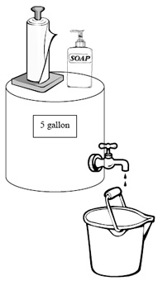
Home Prepared Food Is Not Allowed.

Handwashing Set Up

Set up the handwashing station before any food preparation begins.
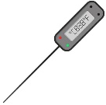
Use a sink with warm running water or a 5-gallon container with a free-flowing spout (no push-button types). Provide a container to catch the wastewater, hand soap and paper towels (no cloth towels). Wash hands for 15 to 20 seconds.
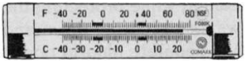
Thermometers

Use a probe thermometer to check temperatures when cooking or keeping food hot or cold.
A small-diameter probe thermometer is needed if cooking thin foods, like burgers and fish fillets.
Air thermometers must be placed in all refrigerators and coolers
.

Dishwashing
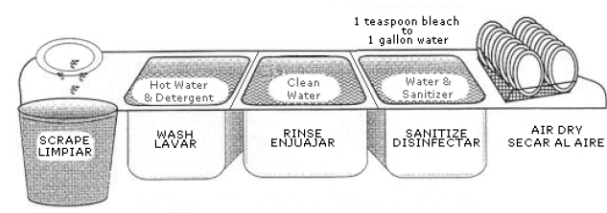
Use a commercial dishwasher, three-compartment sink, or three buckets to clean dishes/utensils. Follow the 3-step process:
- Wash with warm soapy water.
- Rinse with water.
- Submerge in sanitizer
  - For Chlorine / bleach - (50-100 ppm for 10 seconds)
  - For Quaternary Ammonium - (200-400 ppm for 30 seconds)
Test strips are required to check the strength of the sanitizer solution. Air dry dishes after sanitizing.

FEES & SUBMITTALS
FEES ARE SUBJECT TO CHANGE ANNUALLY
FOR AN UPDATED FEE SCHEDULE, VISIT OUR WEBPAGE: https://www.co.marion.or.us/HLT/PH/EHS/Pages/rules.aspx
APPLICATIONS RECEIVED AT LEAST 7 DAYS PRIOR TO THE EVENT WILL QUALIFY FOR A DISCOUNT

APPLICANTS MUST CONTACT OUR OFFICE DURING BUSINESS HOURS AT LEAST ONE FULL BUSINESS DAY PRIOR TO THE EVENT START DATE TO REQUEST A SCHEDULE CHANGE. LATE REQUESTS – INCLUDING THOSE DUE TO INCLEMENT WEATHER OR LOW TURNOUT – ARE NOT ELIGIBLE FOR TRANSFERS, REFUNDS, OR CREDITS

NOTE: A $25 NON-REFUNDABLE ADMINISTRATIVE FEE IS INCLUDED IN THESE FEES.

THIS APPLICATION MUST BE COMPLETED IN FULL AND SUBMITTED WITH FEE:
HOW TO SUBMIT APPLICATION |  | HOW TO PAY
In-Person  Salem Office  (3160 Center St NE)  or the Woodburn Office  (976 N Pacific HWY)  Monday-Friday  8:30am-4:30pm | By Mail  Marion County Environmental Health  3160 Center Street NE Salem, OR 97301 | - CASH – must pay in-person    - CHECK – make payable to “MCEH”  - CREDIT/DEBIT – there is a 2.65% service see for all card payments.  - Phone – Call (503) 588-5346  - Online – See QR code →  Add “TEMP” as the Invoice & Account Number

By Email

EnvironmentalHealth@co.marion.or.us

