
Mental Health Advisory Committee
March 7th, 2024, 12:00 PM– 1:00 PM
In-Person: 2045 Silverton Rd NE, Suite A, Salem, OR 97301 in the Inspirations Conference Room
Recorder: Sam Andress
Attendees: Dr. Satyanarayana Chandragiri Dr. Leon Harrington Nichole Miller Michael Mann Kristin Kuenz-Barber, Co, Co-Chair Earlene Camarillo, Co, Co-Chair Nilly Essaides Jackie Follis Chad Cox
Staff: Phil Blea Ann-Marie Bandfield Ryan Matthews Debbie Wells Sam Andress (R)
Guests: Carly Lair Heidi Johnson Serenia Dotson David Beem
Agenda Item | Notes
Approve minutes from 2/1/24 | Minutes from 2/1/24 approved as written.
Chair Nomination/Vote | Discussion surrounding chair, vice-chair and responsibilities. Jackie Follis volunteers to be considered as Vice Chair, Kristin remaining as Chair for the time being. Motion requested to approve Jackie as Vice Chair, Chad and Earlene motion. All in favor.
IDD Awareness Month Presentation- Carly Lair
Problem Gambling Month- Heidi Johnson | Links:  Youtube: Promotional Video for High School Video Contest  https://youtu.be/iYzKzmQVKPI?si=-h1xf9n3-XCHSypW  Marion County Problem Gambling Prevention Page:  https://www.co.marion.or.us/HLT/PH/PS/gambling  Oregon Health Authority Problem Gambling Page:  https://www.oregon.gov/oha/hsd/problem-gambling/pages/index.aspx  For Problem Gambling Help:  https://www.opgr.org/
Announcements- All | 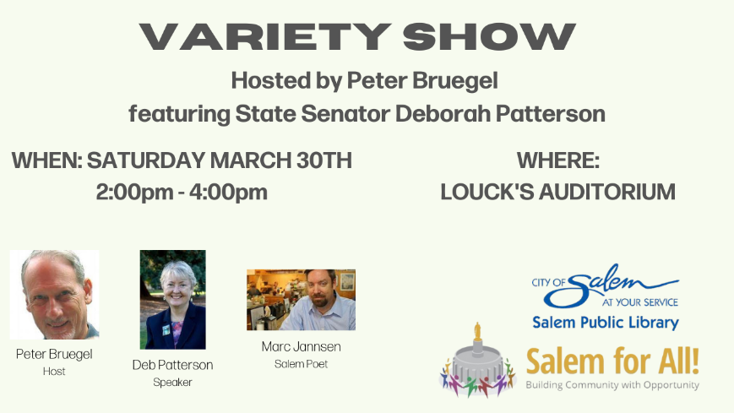  the "Salem For All!" Saturday, March 30th positive Culture and Meaningful experience Variety Show from 2:00 pm to 4:00 pm at the Louck's Auditorium at the Salem Public Library. The Host will be Peter Bergel, American Folk guitarist, Reed College, and speaker Oregon State Senator Deborah Patterson, Poet Marc Jannsens , Salem Poetry Project, Pacific Northwest story tellers and others, and perhaps a presentation from the Salem Art Association about successful Artists in "greater Salem".
Adjourn- Identify Topics for Next Meeting | Discussed topics for April’s meeting. Suggested Alcohol Awareness Presentation, budget update from Ryan, legislation update from Ryan, and Chad mentioned that May is Older Americans month and may have presentation for that topic.
RESPONSIBLE PARTY | ACTION ITEM
Sam Andress | Complete minutes

Next Meeting: April 4th, 2024

Be sure to follow MCHHS on Facebook (@MarionCountyHealth)  and Twitter (@MarionCo_Health)  to see what we're up to!

