Final
October 5th, 2022
Marion County Board of Commissioners Office
Community Development Division
555 Court St.
Salem, OR 97301
https://www.co.marion.or.us/BOC/CD/CDBG
Phone: 503-588-5212
Substantial Amendment #2 to Annual Action Plan Program Year 2021-2022: Marion County HOME-ARP Allocation Plan
Table of Contents

I. Background 2
II. Consultation 2
III. Public Participation 9
IV. Needs Assessment and Gaps Analysis 10
V. HOME-ARP Activities 22
VI. HOME-ARP Production Housing Goals 23
Appendix 24
Public Input Survey Results 25
HOME-ARP Service Provider Input Meeting Letter 35
HOME-ARP Service Provider Input Meeting Minutes 36
HOME-ARP Public Input Meeting Flier 41
HOME-ARP Public Input Meeting Minutes Summary 44
Substantial Amendment #2 HOME-ARP Public Hearing Notice 45
Substantial Amendment #2 HOME-ARP Public Hearing Minutes 46
Comments Received 47

I. Background
On March 11, 2021, President Biden signed the American Recue Plan Act of 2021 into law, which provides over $1.9 trillion in relief for a wide range of issues. Congress appropriated $5 billion of these funds to address the needs of homelessness assistance and supportive services, to be administered through the Department of Housing and Urban Development (HUD). Thus, jurisdictions were presented with a unique opportunity to receive a one-time source of funding to aid in reducing homelessness.
In September of 2021, HUD allocated $2,251,172 of these HOME-American Rescue Plan (HOME-ARP) funds to Marion County. To access the allocated funds, Marion County must create an allocation plan (this document), which will function as a substantial amendment to the County’s 2021 Annual Action Plan. Per program requirements the County was able to allocate $112,558.60 for funding the creation of an allocation plan prior to the plan’s approval by HUD.
Marion County consists of 20 incorporated cities, two of which are not included in this plan. At the time of writing this plan, the City of Salem is its own jurisdiction, and the City of Gates remains under the State program. [The City of Gates is anticipated to be eligible for these funds starting July 1, 2023, due to the fact that on July 7th, 2022, the City of Gates requested to be part of Marion County’s program. At this time, the County is waiting for final approval of their participation from HUD.]

II. Consultation
Before developing its plan, the participating jurisdiction (PJ) must consult with the Continuum of Care(s) [CoC(s)] serving the jurisdiction’s geographic area, homeless and domestic violence service providers, veterans’ groups, public housing agencies (PHAs), public agencies that address the needs of the qualifying populations, and public or private organizations that address fair housing, civil rights, and the needs of persons with disabilities, at a minimum. Local PJs must consult with all PHAs (including statewide or regional PHAs) and CoCs serving the jurisdiction.
A. Summarize the consultation process:
In the month of January, shortly after Marion County was notified of its allocation of HOME-ARP funds, the County presented information to the local CoC regarding the requirements and opportunities of HOME-ARP. The County also sent out a survey directly to approximately 40 service providers – all of which are regular attendees of the local CoC’s meetings – seeking their input.
Unfortunately, only five service providers responded to the survey that was available via Marion County’s website for approximately two months. Two public meetings were held in late spring, the first, which took place on May 19th, 2022, was focused on engaging interested service providers in a meaningful consultation. 24 organizations attended this meeting. The second public meeting was held on June 7th, 2022, and was focused on engaging and receiving feedback from local citizens on possible meaningful uses for HOME-ARP funds. Only two citizens attended this meeting. Feedback was also received through a range of one-on-one consultations with service providers
The public comment period is set to begin on August 19th, 2022, and close 30 days later, on September 20th, 2022. The public hearing is set for September 21st, 2022.
B. List the organizations consulted, and summarize the feedback received from these entities.
Agency/Org Consulted | Type of Agency/Org | Method of Consultation
Applegate Landing LLC  (non-profit) | Private organization that addresses fair housing | Attended May 19th Input Meeting
ARCHES  (non-profit) | Homeless service provider | Used ARCHES’ Community Assessment, 2021 update document to inform this plan
Court Appointed Special Advocates (CASA): For Children  (non-profit) | Private organization that addresses civil rights  Private organization that addresses the needs of qualifying populations – at-risk and other | Used CASA’s 2020-2021 Annual Report to inform this plan
Center for Hope and Safety  (Non-Profit) | Domestic violence service provider  Homeless service provider | Survey  Attended May 19th Input Meeting
Mid-Willamette Valley Homeless Alliance (lead agency for CoC) | Continuum of Care (CoC) | Used the CoC’s 2021 Gaps Analysis, 2021 and 2022 Housing Inventory Count (HIC), and 2022 Point in Time (PIT) Count to inform this plan  Attended monthly CoC meetings
Easterseals Oregon  (Non-Profit) | Homeless Service Provider  Veterans’ group  Private organization that addresses the needs of persons with disabilities | Attended May 19th Input Meeting
Marion County Health and Human Services (HHS) | Public agency that addresses the needs of those with disabilities  Public agency that addresses the needs of all qualifying populations | Attended May 19th Input Meeting  Used the HHS’s Community Health Improvement Plan (CHIP) and Community Health Assessment (CHA) documents to inform this plan
Marion County Public Housing Authority | Public housing agency  Public agency that addresses the needs of all qualifying populations | Attended May 19th Input Meeting
Marion County Sheriffs’ Office | Public agency that addresses the needs of qualifying populations – domestic violence, at-risk, and other | Used the Sheriffs Office’s 2020-2021 Average Monthly Releases document to inform this plan
Marion County Veterans’ Service Office | Veterans’ group | Attended May 19th Input Meeting
Neighbors Serving Under-Sheltered Neighbors  (Non-Profit) | Homeless service provider | Survey  Attended May 19th Input Meeting
Salem Public Housing Authority | Public housing agency  Public agency that addresses the needs of all qualifying populations | Invited to the May 19th Input Meeting  1-on-1 consultation
Shangri-la  (Non-Profit) | Private organization that addresses the needs of persons with disabilities | Survey
Soaring Heights | Homeless service provider | Attended the May 19th Input Meeting  Attended Public Hearing for 2022 Annual Action Plan  1-on-1 consultation
Sunny Oaks  (Non-Profit) | Private organization that addresses the needs of persons with disabilities  Homeless service provider | Email correspondence
Tidy Vibe Tribe / Adopt an Addict | Not enough information available to categorize | Survey
Union Gospel Mission – UGM  (Non-Profit) | Homeless service provider | 1-on-1 consultation
Women at the Well Grace House  (Non-Profit) | Homeless service provider | Survey

Category/Source | Feedback
Center for Hope and Safety – CHS | - All eligible activities are equally important.  - Top cause of homelessness heard from clients: Domestic violence and human trafficking. This group is not usually visible on the streets, but remains a very vulnerable population nonetheless.  - CHS would like support to expand non-congregate and permanent housing options for victims of domestic violence (DV) and human trafficking. This organization is also looking to expand staffing to better reach the rural areas of the county.  - Housing gap: CHS sees an existing need for an additional 50 units of transitional housing and 100 units of permanent housing for victims of DV/human trafficking.  - Other concerns include providing funding for prevention services and the necessary staffing to run those services, along with a general need to provide better funding to improve services in the county.  - At the public input meeting, a representative of CHS explained how her clientele need affordable housing options to escape a violent environment.  - CHS is in the process of constructing 16 units with Salem Public Housing Authority, along with an additional 4 units of affordable housing.  - CHS is looking for additional funding for Project Turnkey – a project that will convert a hotel into non-congregate shelter
Continuum of Care – led by Mid-Willamette Valley Homeless Alliance | Used their documents to inform this plan:  - 2022 and 2021 PIT Counts  - 2021 and 2022 HICs  - 2021 Gaps Analysis  Based upon analysis of this data, there is a need for additional affordable housing options and health services.  See CoC meeting minutes for full details of range of issues discussed
Easterseals | - At the public input meeting, representatives expressed the needs of their organization that offers services to homeless veterans and the need of affordable housing and to gain further knowledge of the CDBG/HOME/HOME ARP programs.  - Dishonorably discharged veterans are a group that this organization is unable to assist but has identified as an at-risk population that is often in need of assistance.
Marion County Health and Human Services – HHS | Used their documents to inform this plan – an action which was suggested by HHS themselves as part of their feedback. Specifically, information regarding:  - Rising opioid usage among homeless  - Overall correlations between housing and health and related statistics/trends  - Youth homelessness  - Lack of affordable housing
Marion County Public Housing Authority | - At the public input meeting, a representative discussed the need for affordable housing and having the ability to preserve aging affordable housing.  - The Housing Authority has a number of properties throughout Marion County that need rehabilitation and capital improvement, and to improve them, it is critical to have access to funds.
Marion County Sheriffs’ Office | - Used their documents to inform this plan – average daily releases from the Marion County Jail, recorded as monthly averages for the year 2020.
Marion County Veterans’ Service Office | - Mentioned that there is a 34-unit veterans’ housing complex being built in Salem, which they are breaking ground for in June, 2022.
Neighbors Serving Under-Sheltered Neighbors | - The most important eligible activities are rental housing, supportive services, and tenant based rental assistance.  - Top cause of homelessness heard from clients: Financial reasons  - Neighbors is currently looking to expand but needs funds to support a housing navigator and outreach team and expand wrap-around services.  - Need 100 more housing units (type not specified)  - Need more people assisting people find affordable housing, going through the whole application process with them (an advocate)  - Chronically homeless – this is most of the homeless population here, and since they face so many barriers to becoming housed, will need long term assisted living services to become housed.  - At the public input meeting, a representative discussed her organization and the importance of meeting the immediate needs of the Woodburn community. The idea for a future project that includes non-congregate shelter on a piece of property that her organization has the use of. She would like to partner with a developer to discuss this project.
Salem Public Housing Authority | - Salem Public Housing Authority has initiated the process with HUD to grant 16 project-based housing units, for the Hope Plaza project, which is being managed by Center for Hope and Safety for qualifying populations.
Shangri-la | - The most important eligible activities are rental housing and supportive services.  - Top cause of homelessness heard from clients: Lack of affordable housing for people on fixed incomes.  - Other concerns include a need to improve the availability of community mental health services, and to help families maintain their housing so they do not become homeless in the first place.  - This organization is currently looking to expand but needs additional funding for supportive services and permanent supportive housing. A second element would be the creation of an incentive for landlords to rent to their participants.
Sunny Oaks | - Consultation in November-December about a number of housing units that Sunny Oaks’ clients may lose access to (these units house disabled individuals), as the landlords are looking to sell the properties due to the expiration of their current contracts. Thus, a number of disabled individuals would be displaced with no immediate place to move to, possibly rendering them homeless.
Tidy Vibe Tribe / Adopt an Addict | - The most important eligible activities are rental housing, non-congregate shelter, and supportive services.  - Respondent emphasized how diverse the homeless population is but pointed to a few specific key issues such as mental health struggles, a sense of shame, and a lack of alternatives to city-life homelessness.  - Funds should be targeted toward those with the motivation to become a functioning member of society, specifically those who do not qualify for other forms of assistance.  - Respondent specifically was looking for more rural work plus housing opportunities, such as helping to upkeep national parks while living on site. Job Corp type of opportunities for those over the age of 27 as well were also mentioned.
Union Gospel Mission – UGM | - Most critical needs heard from clients: Additional family units in emergency shelter (especially for parenting women) and mental health supportive services.  - Additional feedback included a comment on how the CoC’s approach to resolving homelessness is too piecemeal, and that the system overall lacks a “continuum process”. Meaning, steps such as quality transitional housing are missing, therefore it is difficult for clients to seamlessly transition from actively homeless all the way to thriving in permanent housing.  - In this organization’s experience, they and other partner organizations believe women constitute 50% or more of the homeless population. (PIT Count data does not reflect this)  - Discussed potential projects that UGM is in the planning stage for, explored if and how they would qualify to apply for various sources of community development funding, including HOME-ARP.
Women at the Well Grace House | - The most important eligible activities are non-congregate shelters, supportive services, and non-profit operating and capacity building assistance. This organization pointed specifically to a need to add self-sufficiency focused sheltering, especially for women and youth.  - Top cause of homelessness heard from clients: Domestic violence/sexual assault/sex trafficking  - This organization is currently looking to expand but needs funding to do so.

Summarize feedback received and results of upfront consultation with these entities:
A consistent theme raised in numerous consultations was the need for more:
- Supportive services
- Affordable housing
- Non-congregate shelter
Many organizations consulted are looking to expand supportive services, but there are few concrete affordable housing or non-congregate shelter projects in the works that organizations are ready to apply to the jurisdiction for funding.

III. Public Participation
In accordance with Section V.B of the Notice (page 13), PJs must provide for and encourage citizen participation in the development of the HOME-ARP allocation plan. Before submission of the plan, PJs must provide residents with reasonable notice and an opportunity to comment on the proposed HOME-ARP allocation plan of no less than 15 calendar days. The PJ must follow its adopted requirements for “reasonable notice and opportunity to comment” for plan amendments in its current citizen participation plan. In addition, PJs must hold at least one public hearing during the development of the HOME-ARP allocation plan and prior to submission.
For the purposes of HOME-ARP, PJs are required to make the following information available to the public:
- The amount of HOME-ARP the PJ will receive,
- The range of activities the PJ may undertake.
Throughout the HOME-ARP allocation plan public participation process, the PJ must follow its applicable fair housing and civil rights requirements and procedures for effective communication, accessibility, and reasonable accommodation for persons with disabilities and providing meaningful access to participation by limited English proficient (LEP) residents that are in its current citizen participation plan as required by 24 CFR 91.105 and 91.115.
A. Describe the public participation process, including information about and the dates of the public comment period and public hearing(s) held during the development of the plan:
- Date of public notice: August 17th, 2022
- Public comment period: August 19th, 2022 – September 20th, 2022
- Date of public hearing: September 21st, 2022
[Image or link to the image of the public hearing notice in the newspaper – to be added]
B. Describe the public participation process and efforts to broaden public participation:
Public Input Survey:
The survey was available via Marion County’s website for approximately two months.
For the complete survey results, please refer to the “Public Input Survey Results” page in the Appendix below. A summary of feedback received is available above under the “Consultations” section.
Public Input Meeting:
Fliers for the June 7th, 2022, public meeting were delivered approximately three weeks in advance (5/11-13/2022) to all incorporated cities that are part of Marion County’s entitlement jurisdiction. They were publicly posted in either the local city hall, post office, library, or a mix of all three. English and Spanish versions of the flier were also available on the Marion County website, as a digital advertisement in the Statesman Journal, and as a physical, printed advertisement in the local Woodburn newsletter.
A digital copy of the flier is included in the appendix.
The two attendees of the public input meeting heard about the meeting through a flier they received. Overall, a wide range of ongoing community improvement efforts were discussed, not just those directly pertaining to HOME-ARP.
Regarding homelessness, one attendee expressed concern for mental illness among the homeless and a desire to see real solutions to homelessness in general. A question was raised if there was data that demonstrates the effectiveness of providing services to qualifying populations. Concern was also expressed regarding whether the PIT Count accommodated multi-lingual access.
No direct answer received to the question of where specifically the money should be spent.
Public Comment Period:
[To be added]
Public Hearing
[To be added]
D. Summarize any comments or recommendations not accepted and state the reasons why:
As of this time, all comments were accepted.

IV. Needs Assessment and Gaps Analysis
In accordance with Section V.C.1 of the Notice (page 14), PJs must evaluate the size and demographic composition of all four of the qualifying populations within its boundaries and asses the unmet needs of each of those populations. In addition, a PJ must identify any gaps within its current shelter and housing inventory as well as the service delivery system. PJs can use data sources such as the Point-In-Time (PIT) Count, Housing Inventory Count (HIC), or other data available through CoCs, and consultations with service providers to quantify the individuals and families in the qualifying populations and their need for additional housing, shelter, or services.
A. Describe the size and demographic composition of qualifying populations within the PJ’s boundaries:

- Homeless as defined in 24 CFR 91.5
Overview:
In January of 2022, there were a total of 1,805 individuals, or 1,612 households, recorded as homeless in Marion and Polk Counties combined. In comparison, only 1,554 people were counted as homeless in 2021, indicating that there was a 16% increase in the homeless population over the last year alone. Of the total 1,805 individuals, 879 were unsheltered and 926 were sheltered. Of those sheltered, 37% (679) were in emergency shelter, 13% (228) were in transitional housing, while 1% (19) were in Safe Haven beds.

It is important to note that this data is not perfectly reflective of the homeless population for Marion County, as it is combined with Polk County data.

Gender:
A disproportionately greater number of men are currently homeless when compared to women. In the 2022 PIT Count, 35% of those recorded were women, while 64% were men. In comparison, census data for Marion County indicates a near even 50-50 split between men and women. This overall trend among the homeless held true across all housing categories (emergency, transitional, Safe Haven and unsheltered). Only 21 individuals identified as either gender questioning, transgender, or as neither singularly male/female (non-binary, genderfluid, agender, culturally specific gender), constituting 1.16% of all homeless. 13 of these 21 individuals were unsheltered.
*Feedback received from service providers indicates that the ratio of homeless men to women is skewed toward women, not men.

Household Composition:
A minority – 5% – of those experiencing homelessness in 2022 are children under the age of 18 according to the PIT Count. Of the total 1,612 households counted, only 54 had at least one adult and one child. 52 of these family households were sheltered, mostly in emergency shelter. According to the previous year’s Coordinated Entry data (June 2021), 36% of homeless families (27 out of 76 families) were chronically homeless.
Additional relevant statistics include unaccompanied children/youth and parenting youth data from the PIT Count. In 2022, there were 87 unaccompanied children/youth counted, and the biggest subset of this population was 46 unsheltered youth (age 18 to 24). Of the 13 parenting youth households counted, all were sheltered at the time of the Count, mostly in emergency shelter. However, additional data available from school districts indicates that a greater number of children than recorded by the PIT Count are homeless, though they still constitute a minority of all children in Marion County.
The totals written in the chart “K-12 Total Homeless Count…” below reflect the number of school-age children in shelters, unsheltered, living in motels/hotels, and unaccompanied. Data for children whose families’ share their household with at least one other family (doubled-up) is available as well, but as it is not a direct indicator of homelessness but rather is an indicator of a population at-risk, it will be analyzed in a subsequent section. The most recent two school years’ data was not available, but the clear trend is that the total number of children in K-12 school facing homelessness has been over 300 individuals in Marion County each year that data was collected.
Twelfth grade had the highest number of homeless students by grade level. Twelfth grade students experienced homelessness at a rate of 38% more than the second highest grade level. Tenth grade experiences the second highest number of homeless students by grade level. The true totals may be higher due to underreporting, and the fact that children not of schooling age or enrolled in a private school are not included in this dataset. They are included in the PIT Count, however.
It is important to note that 70% of adults in the region’s Coordinated Entry System reported experiencing homelessness as a youth.

K-12 Total Homeless Count, by School District (SD) W/out Doubled-Up Count
 | 2019-2020 | 2018-2019 | 2017-2018 | 2016-2017 | 2015-2016
Gervais SD 1 | 11 | 9 | 19 | 12 | 16
Silver Falls SD 4J | 15 | 9 | 5 | 9 | 14
Cascade SD 5 | 34 | 30 | 23 | 2 | 0
Jefferson SD 14J | * | 3 | 2 | 0 | 2
North Marion SD 15 | 9 | 7 | 6 | 3 | 11
Salem-Keizer SD 24J | 251 | 256 | 190 | 262 | 229
North Santiam SD 29J | 2 | 8 | 0 | 5 | 5
St Paul SD 45 | 1 | 1 | 1 | 1 | *
Mt Angel SD 91 | 0 | 4 | 12 | 10 | 25
Woodburn SD 103 | 56 | 72 | 51 | 91 | 125
Total Across Marion County | 379** | 399 | 309 | 395 | 427**
*Suppressed count of 1-5 children (not all SD’s did this)
**For one or more categories, there was a suppressed count of 1-5 children, therefore any totals are only estimates

The County anticipates that the 2020-2021 school year homeless count would be higher due to the catastrophic fires that occurred that year.

Race/Ethnicity:
All groups except those who identify as Asian are proportionally overrepresented among the homeless in Marion and Polk Counties. “Overrepresented” means that these groups constitute a higher percentage of the homeless population then they do of Marion County at large. Regarding ethnicity, Latinos are underrepresented among the homeless, while non-Latinos are overrepresented. This data is slightly skewed by the fact that the PIT Count does not utilize a category for “other” ethnicities, while the county-wide American Community Survey (ACS) survey does. Furthermore, the PIT Count includes homeless populations in Polk County, not just Marion County like the demographic information.

 | Homeless (PIT) |  | County Demographics (ACS)
 | Population | % of Total | Population | % of Total
Non-Hispanic/Latin(o)(a)(x) | 1,547 | 85.71% | 250,180 | 72%
Hispanic/Latin(o)(a)(x) | 258 | 14.29% | 95,740 | 28%
Total | 1,805 |  | 345,920
American Indian or Alaska Native | 97 | 5.37% | 6,836 | 1.98%
Asian | 7 | 0.39% | 7,501 | 2.17%
Black or African American | 68 | 3.77% | 4,161 | 1.20%
Native Hawaiian or Pacific Islander | 38 | 2.11% | 3,821 | 1.10%
White | 1,517 | 84.04% | 233,321 | 67.45%
Other | N/A |  | 47,723 | 13.80%
Multiple Races | 78 | 4.32% | 42,557 | 12.30%
Total | 1,805 |  | 345,920

Data from the 2021 PIT Count and from the 2020 Census
Homeless = unsheltered and those in emergency shelter, Safe Haven beds, or transitional housing

Veterans:
The majority of homeless veterans are male and white, which follows overall population trends among the homeless. While veterans do have a marginally lower rate of chronic homelessness as opposed to the homeless population at large (34% as opposed to 37%), it is important to note that 26% of those facing chronic homelessness are veterans. In the 2022 PIT Count, 170 veterans were counted as homeless, 68 of which were unsheltered.

Chronic Homelessness:
According to HUD, individuals experiencing “chronic homelessness” refers to either (1) an unaccompanied homeless individual with a disabling condition who has been continuously homeless for at least one year, or (2) an unaccompanied individual with a disabling condition who has had at least four episodes of homelessness in the past three years.
In total, 660 individuals were recorded as chronically homeless in the 2022 PIT Count for Marion and Polk Counties, of which 53% are unsheltered. These 660 individuals account for approximately 37% of the total homeless population. This represents a 6% decrease from the previous year (43%), but at the same time it represents a sharp absolute increase from the 352 individuals counted as chronically homeless the previous year.
The percentage is lower despite this absolute increase because the total homeless population counted in 2022 is significantly higher than the total counted in June 2021. Increases match up with overall trends in Oregon, which indicate that there have been absolute increases in the size of the chronically homeless population for at least the last few years. According to ARCHES, social and economic factors that contribute to chronic homelessness include:
• Insufficient income and low paying jobs
• Lack of affordable housing/Eviction
• Domestic Violence/Divorce/Relationship issues
• Drugs and alcohol and health/mental health issues (see next section, “Illnesses”)
• Impact of service in the armed forces (see previous section, “Veterans”)
• Previous incarceration

Illnesses:
While only a minority chose to self-identify during the 2022 PIT Count as struggling with a substance abuse disorder or having a serious mental illness (~110 total instances, some likely overlapping), more in-depth research shows health is a serious issue among the homeless in Marion County. First it is important to know that mental health distress in adults is strongly correlated with income. According to the CHA, individuals living in poverty – which most homeless are – experience 200% more frequent mental distress than those living above the poverty line.
In Marion and Polk County specifically, Coordinated Entry (CE) data indicates approximately a quarter of those who are homeless experience a serious mental illness (24%) or a quarter experience chronic substance abuse (26%). Participants in work groups for the 2021-2025 CHIP also noted that opioid availability and use seem to be on the rise, particularly within the homeless population.
Among those who are unsheltered and experiencing chronic homelessness, mental and behavioral health issues are top contributing factors to their unsheltered status. Conditions frequently include trauma, substance abuse disorders, psychiatric conditions, violent behavior, and other public health and safety concerns.

Pets:
According to the 2021 CoC Gaps Analysis, sheltering with pets has also been an increasing need in Marion and Polk counties. Many experiencing unsheltered living will prefer to remain unsheltered than abandoning their pets. In response to this trend, ARCHES and other providers began distributing pet food among their other tangible goods and services offered to those experiencing various levels of homelessness and housing insecurity.
Although, it is important to point out that a few shelters are willing and able to accommodate animals. For example, the Center for Hope and Safety runs a program called Safe Paws that provides kennels at their emergency shelter, and they also accept pets at their Mosaic shelter. CHS also always accepts service and emotional support animals.
However, shelters allowing pets are still in high demand and a major gap to individuals seeking and receiving services.

- At Risk of Homelessness as defined in 24 CFR 91.5
While there a number of characteristics that may identify an individual at-risk of homelessness, a few of them include:
- Income that is at or below 30% Area Median Income (AMI)
- Insufficient support networks (i.e., family, friends)
- Living in overcrowded housing (1.5+ individuals per room)
- Living unassisted in a motel or hotel
- Exiting a (mental) health care facility, foster care, or corrections
- Living in another family’s home due to economic hardship
- Having moved 2+ times in the last 60 days
- Having been notified of termination of lease within the next 21 days

According to 2014-2018 CHAS data, 10,145 households (HHs) were living on an income of 30% or less of AMI (Area Median Income) in Marion County. 7,165 were renters, while 2,980 were homeowners. Combined, these 10,145 households compose 8.7% of the total population.

HHs at or below 30% HAMFI
 | Owner | Renter | Owner / Renter Combined
Household Income ≤ 30% HAMFI | 2,980 | 7,165 | 10,145
% Population at ≤ 30% HAMFI | 4.3% | 15.1% | 8.7%
Total Population Size | 69,495 | 47,365 | 116,860

Overcrowding/Doubled-up Count:
According to the 2014-2018 CHAS data, 1% of all occupied housing units are overcrowded, at 1.51 or more occupants per room. This breaks down to 430 owner-occupied and 829 renter-occupied households. During the school year of 2019-2020, there were 1,379 school-age children in Marion County public schools that were living doubled up.

Corrections:
In 2020, the average daily releases from jail ranged from 10-15 people a day from January to March, and then tapered off to an average of two or less for the remainder of the year.
Youth Transitioning Out of Foster Care:
Youth transitioning out of foster care are also considered to be at-risk of homelessness. Youth transition out of foster care anywhere from the age of 18 to 21 (21 with a court order). According to the State of Oregon, 312 people exited foster care in Marion County in the year 2020. Only 5.6% of those exiting care statewide did so due to aging out or other reasons. While no specific statistic for Marion County is available, if the state-level trend held true locally, then approximately 18 youths aged out of foster care in 2020 in Marion County (~201 aged out state-wide). As a note, state-level data does not include Title IV-E eligible children served by Tribes. From the year 2015-2020, the percentage of youths aging out or exiting care for other reasons has ranged from 5.3-8.3%, with an average of 6.5% state-wide.
Hotels/Motels:
It is unclear how many individuals are living unassisted in motels or hotels, but the number of vouchers available is likely decreasing due to a lack of funds. Funds had originally increased due to Covid-19 and wildfire recovery funds.
Project Turnkey is an example of this shelter expansion. This state-run program funded two new emergency shelters in Marion County: the Mosaic Center run by the Center for Hope and Safety and the ARCHES Inn run by ARCHES. Both shelters opened in the summer of 2021. The State Legislature allocated an additional $50 million for Project Turnkey 2.0 in 2022. Applications are due in August of 2022 to Oregon Community Foundation.
The current number of hotel/motel housing voucher beds counted in the 2022 PIT Count total 73 year-around beds and 6 overflow beds.

- Fleeing, or Attempting to Flee, Domestic Violence, Dating Violence, Sexual Assault, Stalking, or Human Trafficking, as defined by HUD in the Notice
During the 2022 PIT Count, staff asked individuals if they would voluntarily choose to identify themselves as being an adult survivor of domestic violence. 120 individuals answered yes to this question. Of those 120 individuals, 21 were in emergency shelter, 8 in transitional housing, 1 in a Safe Haven bed, and 90 were unsheltered.
Looking at this question from a different angle, during the PIT Count 184 of the 192 beds for domestic violence/human trafficking survivors were occupied. It is unclear how many of these individuals also answered the optional demographic question mentioned above.
The only provider of domestic violence and human trafficking services in Marion County is the Center for Hope and Safety (CHS). CHS estimates that they receive an average of 30,000 contacts to their program each year for the last four years, which totals over 549,596 contacts over the history of the organization, as of 2022. Over this last year alone, CHS provided 9,519 nights of shelter to those in need of it, which is a significant increase from the past year’s total of 3,681 nights of shelter. This increase was due to the addition of the Mosaic shelter. CHS also indicated during consultation that there is a need for an additional 50 units of transitional housing and 100 units of permanent housing for victims of DV/human trafficking. These 150 units would be in addition to the 20 new units that the HOPE Plaza project will create.
Thus, if PIT Count data is taken into consideration alongside the data from CHS, then the current need in Marion County for DV/human trafficking shelter could be a minimum of 362 beds.
- Other populations requiring services or housing assistance to prevent homelessness and other populations at greatest risk of housing instability, as defined by HUD in the Notice
The category of “other populations” contains a number of characteristics that overlap with the earlier “at-risk” category. The unique characteristics include:
- Need housing assistance to stay housed
- Severe cost burden at 30% or less AMI
- 50% or less AMI
Severe Cost Burden:
A household is cost burdened if they spend 30% or more of their income on housing related expenses. This becomes a severe cost burden if they spend 50% or more of their income on housing related expenses. At 30% AMI, there are 7,125 households in Marion County that are severely cost burdened. Of these 7,125 households, 5,120 are renters and 2,005 are homeowners. In total, approximately 6% of households are severely cost burdened in Marion County, according to 2014-2018 CHAS data.
The chart below, “Housing Cost Burden by Income Group”, illustrates that while the number of households with a severe cost burden decreases as AMI increases, this is not necessarily true for households that are cost burdened. Until reaching 80% or more AMI, the number of households facing a cost burden increases with each AMI increase.

50% or less AMI:
According to the most recent CHAS data, there are a total of 22,200 households living at or below 50% AMI in Marion County, composing 19% of the overall population. 15,160 of these households are renters, and 7,040 are homeowners.
HHs at or below 50% HAMFI
 | Owner | Renter | Owner / Renter Combined
Household Income ≤ 50% HAMFI | 7,040 | 15,160 | 22,200
% Population at ≤ 50% HAMFI | 10.1% | 32.0% | 19.0%
Total Population Size | 69,495 | 47,365 | 116,860
Data sourced from CHAS, 2014-2018 data

B. Identify and consider the current resources available to assist qualifying populations, including congregate and non-congregate shelter units, supportive services, TBRA, and affordable and permanent supportive housing (optional):
- Beginning in 2021, Marion County became its own entitlement jurisdiction, and received CDBG and HOME funds for the first time. These are potentially annual funds that go toward a wide range of community development projects. Additionally, due to recent wildfires FEMA support has helped the community rebuild, as have the recent ARPA funds going toward Covid-19 recovery.
- The local CoC was recently awarded $3.7 million to help combat homelessness for youth in Marion and Polk Counties over a two-year period (2022-2024). This project is led by the Youth Homeless Demonstration Program’s (YHDP) youth-led council, otherwise known as Backbone, and is currently in the stage of finalizing which project applications to fund. There are three project areas covered by this grant: coordinated entry, supportive services, and joint transitional housing/rapid re-housing.
- Local organizations combatting homelessness include ARCHES and Easterseals. ESG funding is available through ARCHES for service providers that work directly with qualifying populations.
- A recent project is to construct 32 Tiny Homes funded through the State.
- There is also disaster recovery funding pending from Community Development Block Grant-Disaster Recovery program, which could go toward housing for disaster victims.
- The vast majority of resources available in this jurisdiction are catalogued in the online database of Mid-Willamette Valley Resources (https://www.midvalleyresources.org/).
- A central focus of the DeMuniz Resource Center is to assist formerly incarcerated individuals, who are more vulnerable to homelessness. There is also a transition center within the Marion County justice system, not just a county jail.
C. Describe the unmet housing and service needs of qualifying populations, including but not limited to:
- Homeless as defined in 24 CFR 91.5
- At Risk of Homelessness as defined in 24 CFR 91.5
- Fleeing, or Attempting to Flee, Domestic Violence, Dating Violence, Sexual Assault, Stalking, or Human Trafficking, as defined by HUD in the Notice
- Other populations requiring services or housing assistance to prevent homelessness and other populations at greatest risk of housing instability, as defined by HUD in the Notice
Affordable Housing:
To explain the present unmet housing needs among qualifying populations, it is important to start at the beginning – a lack of affordable housing options. State-wide there is a profound need for affordable housing, and Marion County does not differ from this trend. It is widely accepted that no more than 30% of a household’s income should go towards housing related costs. An earlier section describes a household paying more than 30% as cost burdened or extremely cost burdened. In Marion County, at least 37,500 households are cost burdened, making up 32% of the population. Clearly, there is a significant need for lower cost housing in Marion County.
Unfortunately, available affordable housing cannot meet the current demand for it. According to the Oregon Housing and Community Services’ (OHCS) Affordable (Rental) Housing Inventory in Marion County (see chart below), there are 3,264 affordable units currently, with another 754 in development. To be clear, for the purposes of the chart below, “affordable housing” is that which was originally funded or put into the affordable housing stock with the support of tax funding (tax credits, grants, and other public dollars), and, in turn, is required to provide rental housing at a “reduced rate” to low-income households for an established period of time. Low-cost housing that is not subsidized is not counted in this total, though it is not commonly found.
Affordable Housing Inventory
 | Total – 2022 | Total - 2019 | Projects Under Development - 2022 | Lost Units Since 2019 Inventory | Gained Units Since 2019 Inventory
# of Units | 3,264 | 2,778 | 754 | 249 | 868
According to ARCHES, this affordable housing crisis disproportionately impacts seniors, people with disabilities, single-parent households, communities of color, and youth. Furthermore, the quality of rental housing is also poor overall, a factor which has a disproportionate impact on low-income households. Lack of options also impacts people with limited English proficiency and people who are undocumented.
Transitioning From Unsheltered to Permanently Housed:
There are also difficulties in assisting individuals transitioning from unsheltered to permanently housed. Setting aside the topic of getting people off of the streets in the first place (see below), the system lacks the capacity to seamlessly transition all those in emergency shelter to transitional housing and later on to permanent housing.
The chart below indicates that in all permanent housing types combined (permanent supportive housing, rapid rehousing, and other permanent housing), there are 473 beds available. According to the 2022 HIC, 470 of those beds are currently occupied, indicating a nearly 100% utilization rate. As such, individuals in transitional housing or emergency shelter have limited opportunities to move onto more permanent and stable housing situations.
Housing Inventory Changes
 | Emergency Shelter | Transitional Housing (includes Safe Haven) | Permanent Supportive Housing | Rapid Rehousing | Other Permanent Housing
Inventory - 2021 | 278 | 382 | 243 | 395 | 6
Current Inventory - 2022 | 754 | 285 | 115 | 235 | 62
Net Changes | (+)476 | (-)97 | (-)128 | (-)160 | (+)56

Pets:
Due to the low number of shelters that allow pets, many individuals choose to remain homeless over abandoning their pets to enter shelters.
Youth:
Data from the CHIP points to an unmet need among homeless students, how their often-untraditional way of finding shelter (i.e., couch-surfing) makes them not count as being homeless. Youth students in unstable housing situations also find it more difficult to access needed resources.
There are also few designated youth beds available in the City of Salem, and as of the 2021 Gaps Analysis, there were none in either Polk County or the rural areas of Marion County. This remains a service gap for this population.

Rural:
The vast majority of services and shelters are concentrated in urban areas, especially the City of Salem. This leaves wide areas of the county with little access to these resources, and as such, it is more difficult to measure their level of need as well.
Families:
Within shelters, there is a limited capacity to handle families, either with or without children, yet there are a significant number of people in this demographic that need assistance. UGM observed that women with children constitute a large percentage of the total women that they serve, but that there is insufficient capacity to handle these families. Couples without children or adult families also face difficulties in staying together, as the majority of shelters are designed to handle single adults (since this is the largest demographic overall among the homeless population).
Healthcare Access:
Data shows that chronic homelessness is often accompanied by the complications of a physical or mental health condition which hinders their ability to be sheltered. Interventions designed to address physical and mental health conditions are needed to help end and prevent homelessness in the community.
Domestic Violence (DV):
According to the Center for Hope and Safety’s best estimates, there is a need for 150 additional DV/human trafficking beds in Marion County.
D. Identify any gaps within the current shelter and housing inventory as well as the service delivery system:
The Mid-Willamette Valley Homeless Alliance – the lead agency for the local CoC – is a relatively new organization. In 2019, Marion and Polk counties withdrew from the large, “balance of state” Rural Oregon Continuum of Care, and the Mid-Willamette Valley Homeless Alliance was created and was successfully designated as a registered, regional Continuum of Care (CoC).
While still a relatively new organization, it has increased the utilization of the Homeless Management Information System (HMIS) by service providers. The utilization rate for year-around beds reported in HMIS was 43% in 2020, which rose to 68% in 2021. Broken down into categories, 100% of permanent supportive housing providers and seasonal shelters utilize HMIS, 75% of rapid rehousing, 46% of transitional housing, and 68% of emergency shelter beds. Since organizations providing shelter for survivors of domestic violence do not use HMIS, coverage rates are calculated without those beds.
The CoC is also working on improving its communication system even further, by constructing a publicly viewable data dashboard. As of this time, there is no estimated completion date for this project.
It is important to note that outside of the City of Salem, there are limited resources available, even in other urban cities. In part due to this lack of resources, it is also a bigger challenge to assess how many are in need of services in rural areas.
F. Identify priority needs for qualifying populations:
Based upon feedback that was received the two eligible categories that are the greatest priority in Marion County are supportive services and non-congregate shelter.
G. Explain how the PJ determined the level of need and gaps in its shelter and housing inventory and service delivery systems based on the data presented in the plan:
Staff discerned the level of need in the community primarily by researching documents created by the Marion County Health and Human Services department, Continuum of Care, Oregon Department of Education, Federal Census Bureau, and the Oregon Department of Human Services, among others. Feedback from consultations also greatly informed the data present within this plan.

V. HOME-ARP Activities
HUD mandates that the PJ detail the method for solicitating applications for funding and/or selecting developers, service providers, sub-recipients, and/or contractors and whether the PJ will administer eligible activities directly.
A. Describe the method(s)that will be used for soliciting applications for funding and/or selecting developers, service providers, subrecipients and/or contractors:
The County will solicit applications for funding through a competitive request for application process.
B. Identify the referral methods that the PJ intends to use for its HOME-ARP projects and activities. PJ’s may use multiple referral methods in its HOME-ARP program. (Optional):
The County will work in conjunction with local service provider partners, who use the local Coordinated Entry system.

C. Describe whether the PJ will administer eligible activities directly:
It is not anticipated for the County to administer eligible activities directly.
D. If any portion of the PJ’s HOME-ARP administrative funds were provided to a subrecipient or contractor prior to HUD’s acceptance of the HOME-ARP allocation plan because the subrecipient or contractor is responsible for the administration of the PJ’s entire HOME-ARP grant, identify the subrecipient or contractor and describe its role and responsibilities in administering all of the PJ’s HOME-ARP program:
No work was contracted out or delegated to a subrecipient, therefore no HOME-ARP administrative funds were provided to a contractor or subrecipient. County staff will be administering the HOME-ARP program. Contractors, subrecipients, and developers will be applying through the RFA process.
E. Use of HOME-ARP Funding
In accordance with Section V.C.2. of the Notice (page 4), PJs must indicate the amount of HOME-ARP funding that is planned for each eligible HOME-ARP activity type and demonstrate that any planned funding for nonprofit organization operating assistance, nonprofit capacity building, and administrative costs is within HOME-ARP limits.
 | Funding Amount | Percent of the Grant | Statutory Limit
Supportive Services | $913,496.20 | X | X
Acquisition and Development of Non-Congregate Shelters | $1,000,000 | X | X
Tenant Based Rental Assistance (TBRA) | $0 | X | X
Development of Affordable Rental Housing | $0 | X | X
Non-Profit Operating | $0 | 0% | 5%
Non-Profit Capacity Building | $0 | 0% | 5%
Administration and Planning | $337,675.80 | 15% | 15%
Total HOME-ARP Allocation | $2,251,172 | X | X

G. Describe how the characteristics of the shelter and housing inventory, service delivery system, and the needs identified in the gap analysis provided a rationale for the plan to fund eligible activities:
Through our analysis, the identified priorities were supportive services and housing. Due to the lack of ready projects, and Marion County being a brand-new entitlement community, non-congregate shelter was prioritized over affordable rental housing at this time.

VI. HOME-ARP Production Housing Goals
A. Estimate the number of affordable rental housing units for qualifying populations that the PJ will produce or support with its HOME-ARP allocation:
At this time, Marion County has not allocated any funds to develop affordable rental housing. As such, no units of affordable rental housing are expected to be produced.
B. Describe the specific affordable rental housing production goal that the PJ hopes to achieve and describe how it will address the PJ’s priority needs:
At this time, Marion County has no affordable rental housing goal, as no funds were allocated to develop affordable rental housing.

Appendix

Public Input Survey Results
Note: The survey results begin with response #2 because response #1 was a test response.
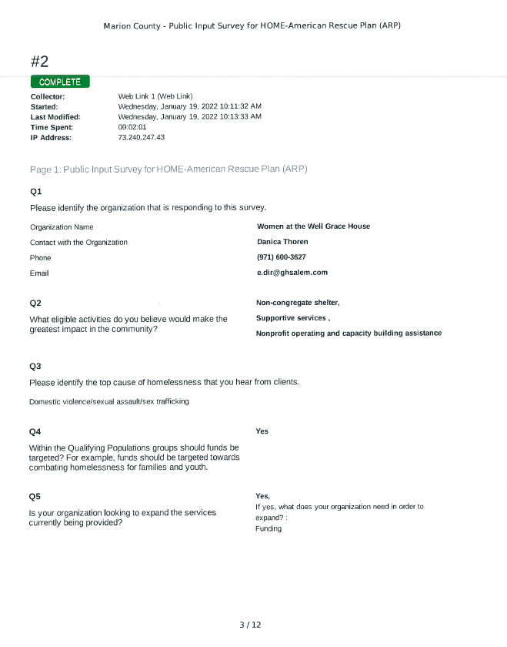
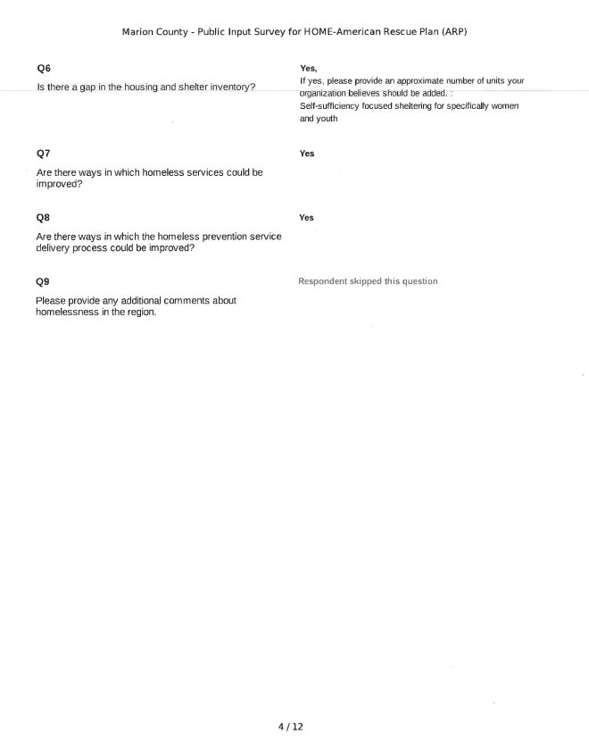

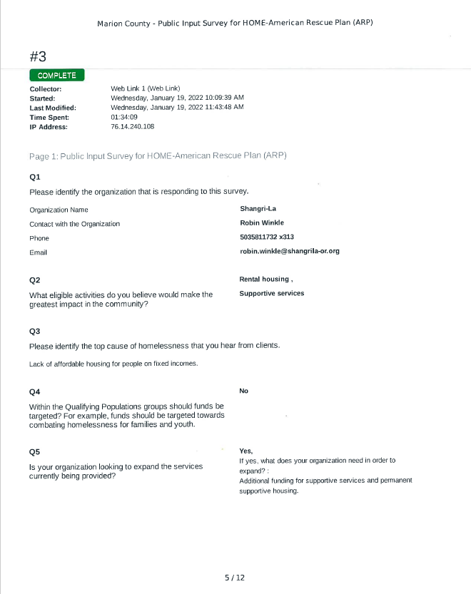

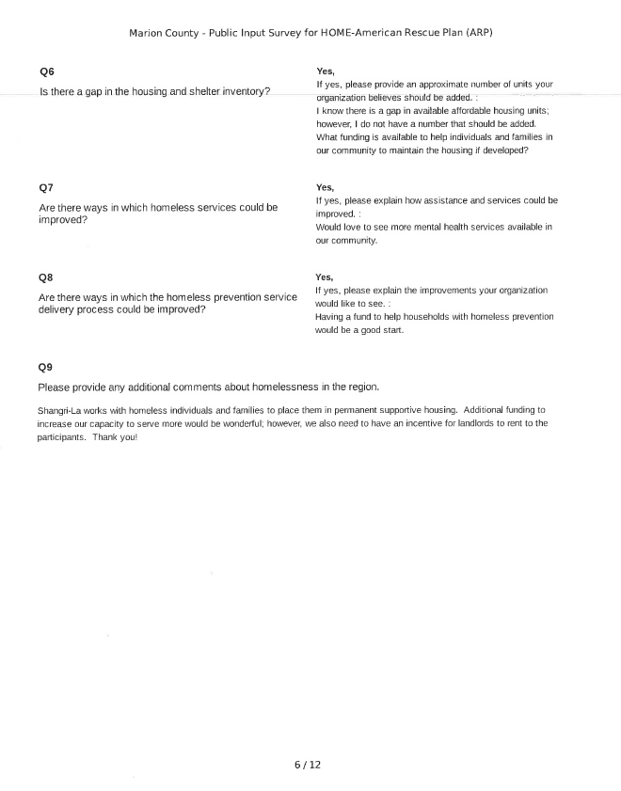
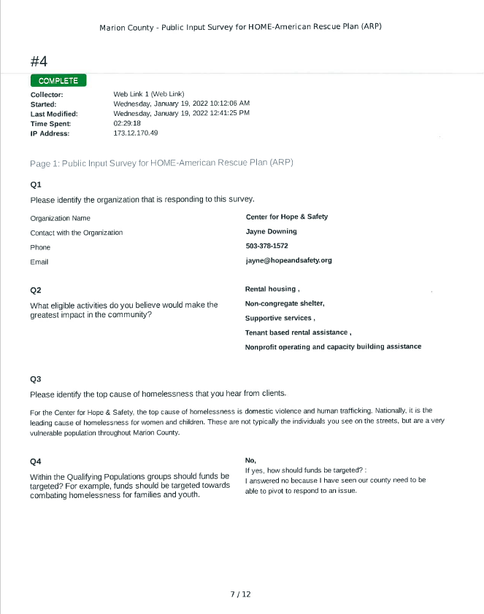

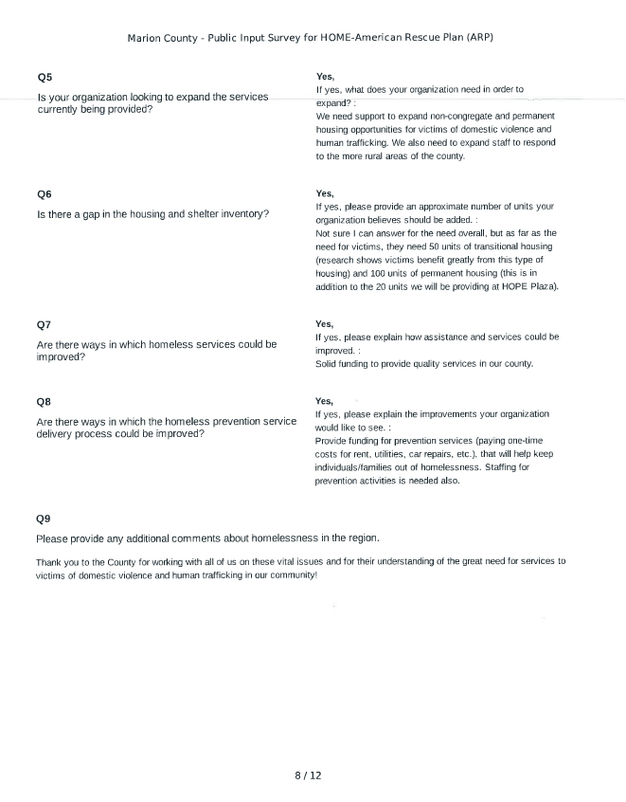

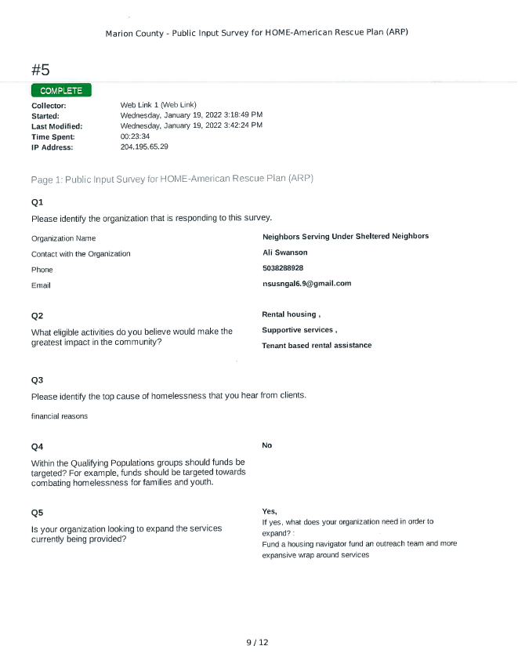

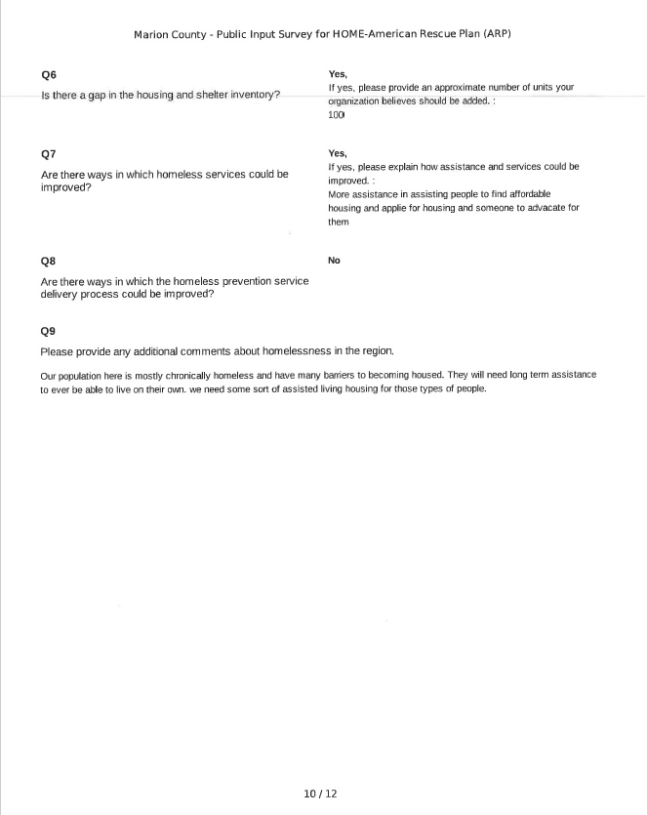
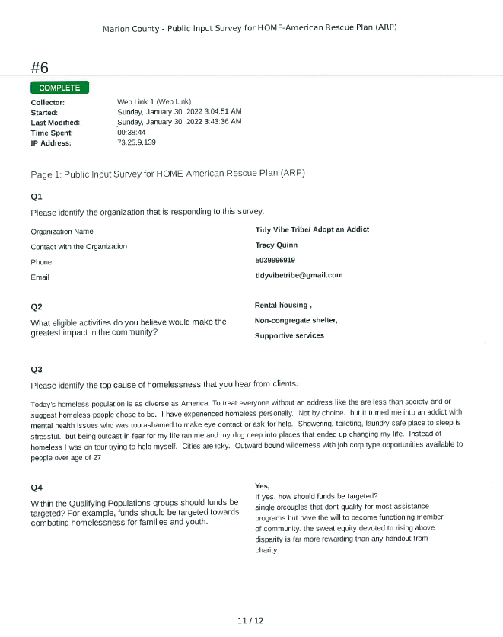

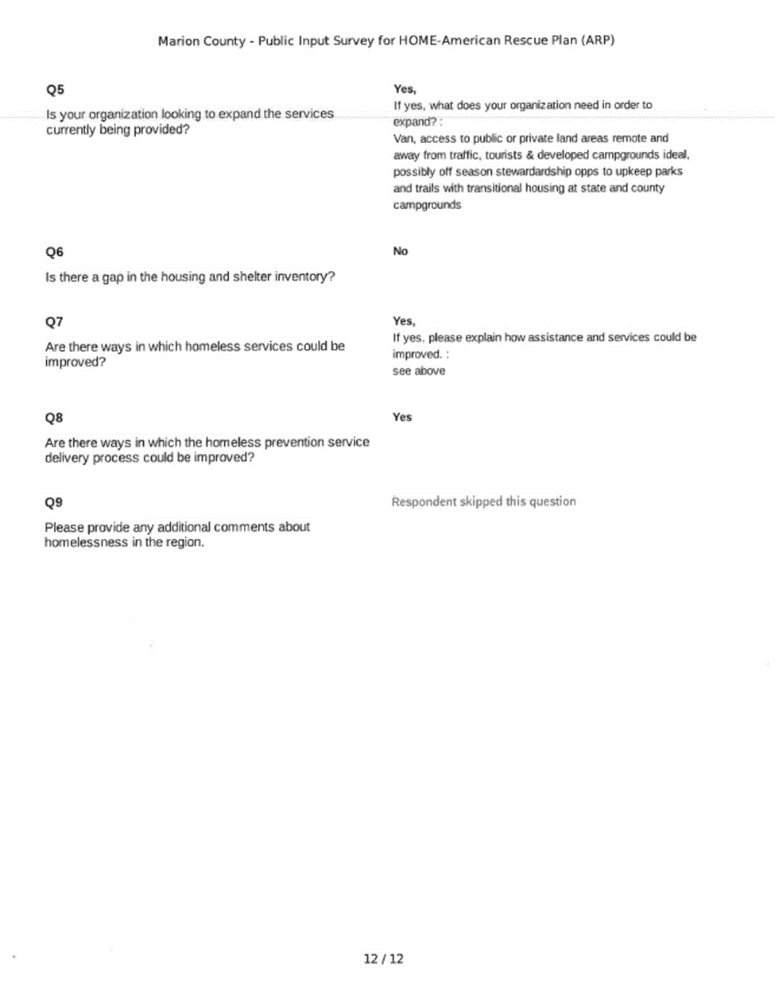

HOME-ARP Service Provider Input Meeting Letter
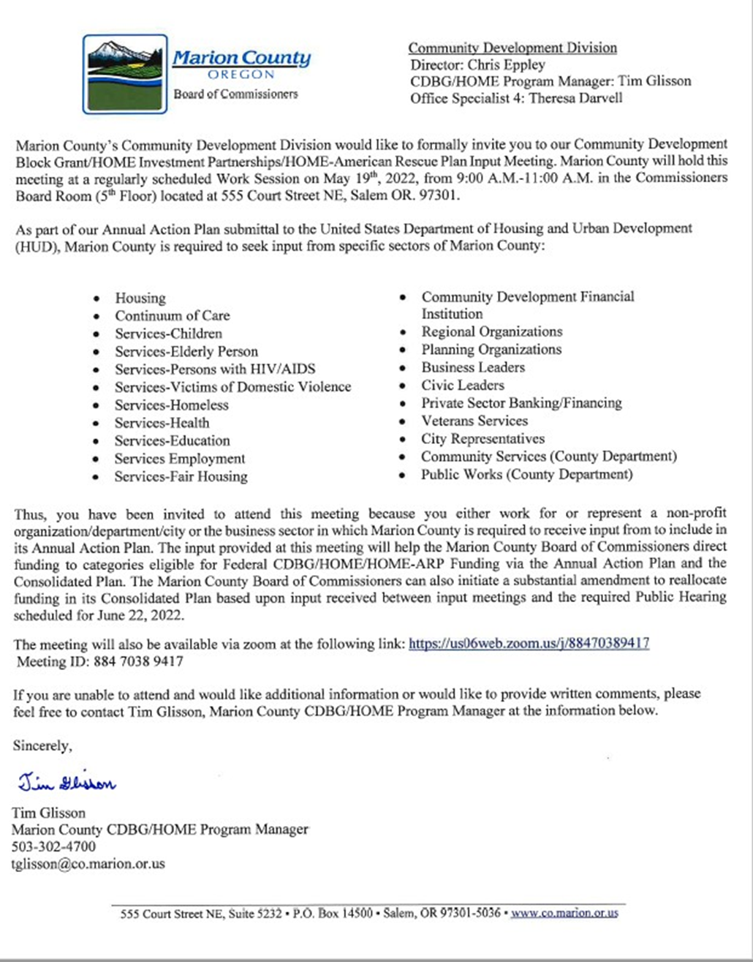

HOME-ARP Service Provider Input Meeting Minutes

CDBG/HOME/HOME-ARP Input Meeting Minutes

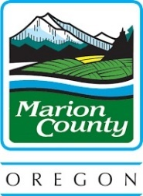
Community Development Division
Board of Commissioners Office
CDBG/HOME/HOME-ARP
Input Planning Meeting

Presenter | Tim Glisson
Location | 555 Court St. NE, Salem  5th Floor, Commissioner’s Board Room
Goal | Gain input of the needs of cities, non-profits and Marion County Departments for CDBG/HOME/HOME-ARP Funding
Thursday, May 19, 2022, 9:00 a.m.

Attendees:

Commissioner Danielle Bethell
Commissioner Kevin Cameron
Chris Epley, Community Development Division Director
Terri Darvell, Community Development Division OS4
Erinn Miller, HOME-ARP OS3
Matt Lawyer, BOC
Jessica Stanton, BOC
Chad Ball, BOC
Jon Heynen, BOC
Tanisha Bush, BOC
Public Housing Authority
Family Building Blocks
Center for Hope & Safety
DevNW
COG
AppleGate Landing LLC
CPAH
Mid-Willamette-Habitat for Humanity
North Willamette-Habitat for Humanity
Love, Inc
Marion County Health & Human Services
Marion County Community Services Dept.
Marion County Veterans Service Office
Crossroads Communities
Easterseals Oregon
Eric Swenson, Mayor of Woodburn
Adam Brown, Keizer City Manager
Dan Fleischman, Stayton Planning and Development Director
Stacie Cook, Mill City Recorder

Board Members of Friends of Historic St. Paul
Eric Rasor, Soaring Heights Recovery Homes
Tami Goettsch, Marion County Community Services Director
Jason Icenbice, Marion County Housing Authority
Cody Walterman, Marion County Legal Counsel
Jane Vetto, Marion County Legal Counsel

Discussion Notes:
Commissioner Cameron Opened the work session (meeting) Tuesday, May 19, 2022, at 9:00 a.m. regarding Marion County’s CDBG/HOME/HOME ARP grant programs
Tim Glisson:
Introduction and explanation of the purpose of the input meeting regarding the use of the CDBG/HOME/HOME-ARP funds and that Marion County is a new entitlement community, as of December 2021. Marion County works in conjunction with the U.S. Department of Housing and Urban Development created a consolidated plan and the need to expand the process regarding the input of the community directly. The Community Development Division will be visiting cities to discuss the needs as well as eligible projects in order to assess the consolidated plan and the annual action plan.
A background of the programs was explained and the eligible activities, how as a county, the Board of Commissioners can allocate the funds in order to meet the needs of communities within Marion County. Explained the necessity of a public hearing, the grant funding timeline and the application process and due dates.
Commission Cameron:
Had a question about the two cities within the Marion County boundaries that are not participating in the grant funding programs
Answer:
The City of Gates opted out and the City of Salem has its own funding program, but that the City of Gates may opt back in if they choose to do so.
Commissioner Bethell:
Asked Chris Eppley to contact Gates to set up a meeting to discuss the option of opting back into the funding programs.
Tim Glisson:
Explained the Consolidated Plan, the priority needs and goals that the Board of Commissioners established, disaster relief, low to moderate income housing, special needs populations, public facilities, infrastructure, homelessness, and economic development.
Guest Ali Swanson NSUSN:
Discusses her organization and the importance of meeting the immediate needs of the Woodburn community. The idea for a future project that includes tiny homes on a piece of property that her organization has the use of. She would like to partner with a developer to discuss this project.
Guest Jason Icenbice, Marion County Housing Authority:
Discusses the need for affordable housing and having the ability to preserve aging affordable housing. The Housing Authority has 11 properties throughout Marion County that are in need of rehabilitation and capital improvement and the importance of having access to block grant funds.
Guest Friends of Historic St Paul:
St Paul has a Creamery that needs restoration and would like to be able to access the grant funds to help this project and how the Creamery would benefit the community.
Tim Glisson:
Explains that the restoration of the Creamery if eligible would fall under the slum and blight national objective.
Guest Stacie Cook, Mill City Recorder:
Wants to get a better understanding of how the grant program works and what projects are considered eligible. She agrees that affordable housing and housing in general is a priority and the needs of Mill City. Mill City is a dual county city and asked how that would work with the grant’s allocation. It was explained that the Board of Commissioners have the jurisdiction. She also asked about the LMI criteria for the city and that as of now, Mill City does not qualify.
Tim Glisson:
Explains the two ways that a city can meet the LMI criteria.
Guest Emily Reiman, DevNW:
Discuses the need for affordable housing and the possibility of land banking as an option for developers and the funding needed for that. She also discussed the need for rehabilitation of older homes in the community.
Guest Marguerite Kenagy, Family Building Blocks:
Provides an overview of her program and the needs and services that benefit child abuse prevention, therapeutic early childhood trauma services, family support, parent education, respite care as well as mental health services. They need a property that can handle all the services mentioned as well as a food pantry and clothes closet. This is a future project to utilize federal funds for a facility.
Guest Renata Wakeley, COG:
Asked to clarify the list of eligible projects under CDBG and the identified priorities of the Board of Commissioners, income surveys. Agrees that land banking is a great option to support affordable housing.
Guest Dan Fleischman, Stayton Planning & Development Director:
Addresses affordable housing needs and infrastructure expansions, the development/rehab of a 72-unit apartment complex in Stayton and the necessity of economic development.
Guest Jayne Downing, Center for Hope & Safety:
Explains how her clientele need affordable housing options to escape a violent environment.
Guest Michael Couch, Crossroads Communities:
Describes his organizations functions, their focus that relates to vulnerable populations, coordinating services, affordable housing, and homeless needs and how they also focus on veteran needs as a priority. They are a developer and partner up with organizations to develop projects that will meet these needs and for long term success. Described the property in Lebanon that is 48 units of affordable housing.
Guest Jerry Ambris, Executive Director Mid-Willamette Habitat for Humanity:
Agrees that affordable housing is a priority and explains that this is the mission of Habitat. He also agrees that land banking is a great option that can lead to affordable housing.
Guest Catherine Todd, Easterseals Oregon:
Introduces herself and her colleague and expresses the needs of her organization that offers services to homeless veterans and the need of affordable housing and to gain a more knowledge of the CDBG/HOME/HOME ARP programs.
Tim Glisson:
Opens the forum by explaining the HOME ARP program and the criteria needed for eligible projects. He also explained the dollar amount he also touched on the need for CHDOs and the benefits of an organization becoming one.
Comments and suggestions made include getting some demographics data using CHIP for LMI areas, homeless population, at risk populations, mental health issues, affordability of rent, unemployment as well as other factors that can help determine the allotment of funds.
It was also stated the need for emergency shelters, transitional housing, permanent housing and reducing barriers.
Positive comments about the meeting and making the connection with not only the Board of Commissioners, but also the different organizations.
Commissioner Bethell:
Adjourned the work session (meeting) at 10:18 a.m. on Tuesday, May 19, 2022.

HOME-ARP Public Input Meeting Flier
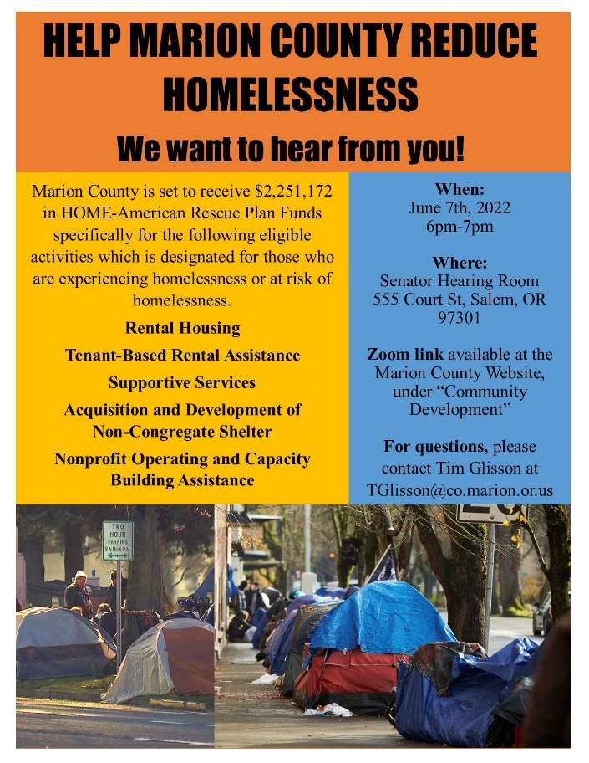
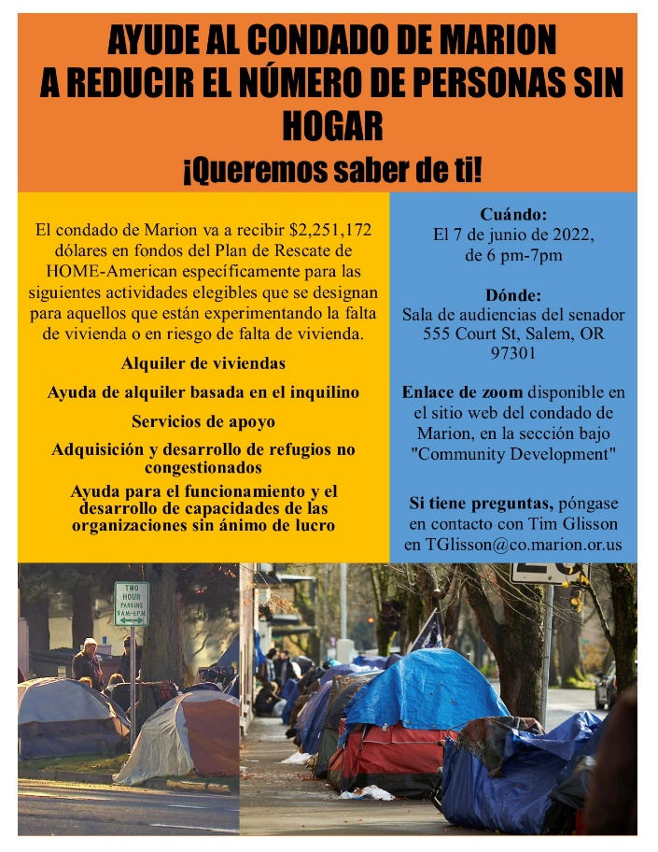

Examples of where fliers were posted:
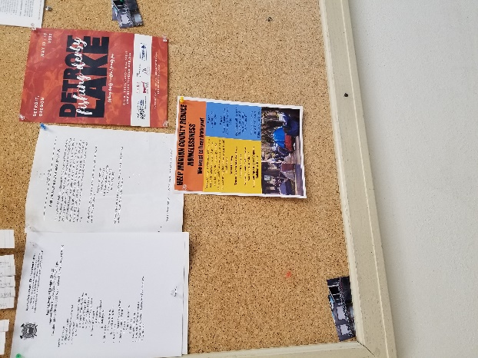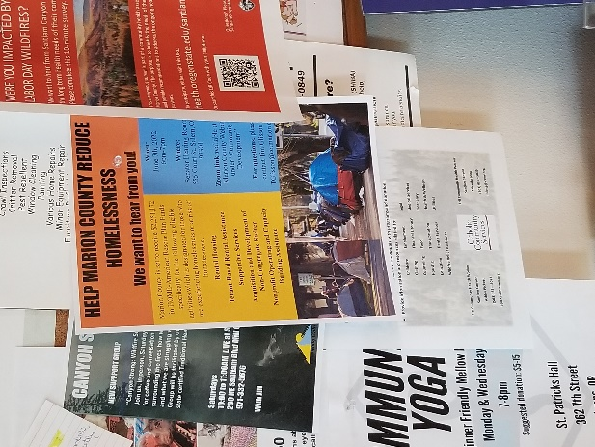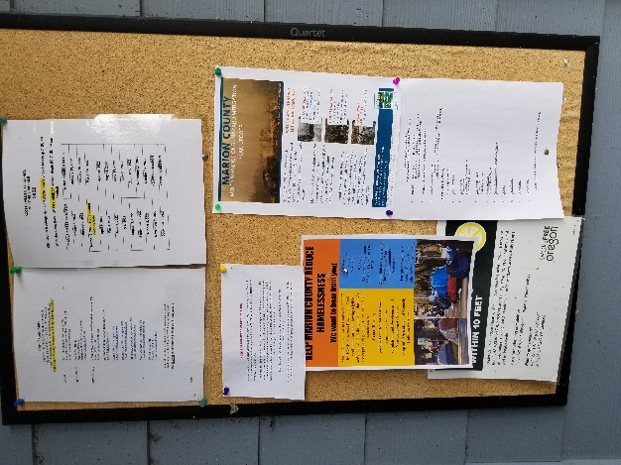
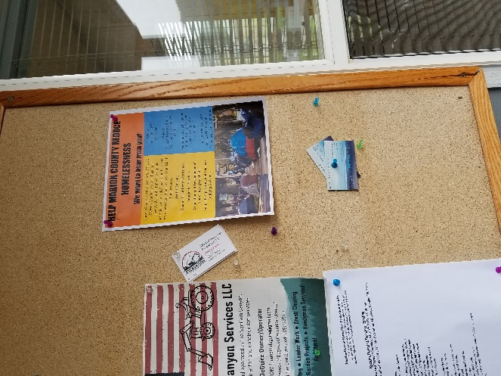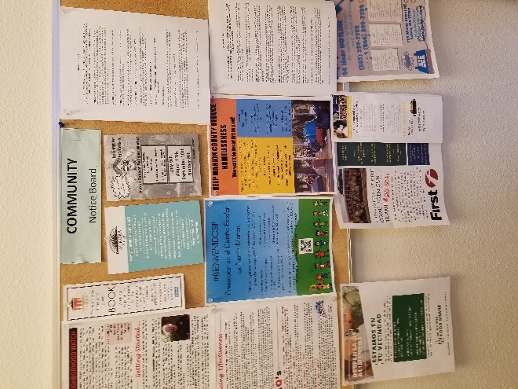

HOME-ARP Public Input Meeting Minutes Summary
The following is a summarization of the HOME-ARP public input meeting held on June 7th from 6-7pm. The precise minutes are not available due to technical issues with the recordings.
Attendees:
Robert Carney – City of Woodburn Council Member
Marilyn Carney – volunteer at St. Vincent de Paul Food Bank in Woodburn
Summary:
- Attendees heard about this meeting through a flier they received
- Q: How prevalent are mental health issues among the homeless?
- Q: Are there any solutions to all the homelessness that we see?
- General discussion of HOME-ARP PPT
- Q: Are any recipients grateful for the assistance they receive? Is there any data behind the programs to show if they do actually help?
- Q: How was grant money allocated to different recipients?
- Discussed ESG funding through ARCHES
- Q: What is the CoC doing?
- Discussed Backbone (youth council) and how the Homeless Alliance is relatively new to the area.
- Q: Did the PIT Count allow for multilingual access?
- No direct answer received to the question of where specifically the money should be spent
- Discussed ongoing community development programs (mostly CDBG) that are currently being run by the County and where money was being spent
- Discussed contents of the Annual Action Plan

Substantial Amendment #2 HOME-ARP Public Hearing Notice

[Scan of Public Hearing Notice – To be added]

Substantial Amendment #2 HOME-ARP Public Hearing Minutes

Please contact the Board of Commissioners office at 503-588-5212 for the Public Hearing Minutes from September 21st, 2022.

Comments Received
