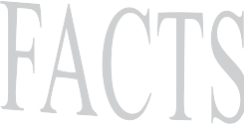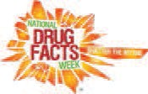**Open to all Marion County middle and high school student groups

C O N T E S T

Did you know that January 23rd - January 29th, 2017 is National Drug Facts Week? Sponsored by the National Institute on Drug Abuse (NIDA), National Drug Facts Week is an annual occurrence inspiring local events to spread awareness about what
SCIENCE has taught us about drug abuse and addiction and “Shatter the Myths” around drugs.

To encourage local participation, Marion County Health Department Prevention Services is hosting a contest. For this contest, local groups are invited to create a fun, youth driven video to share during Drug Facts Week (Jan 23rd-Jan 29th, 2017) that spreads the positive message about healthy choices and the dangers of drug abuse.
CASH PRIZES for the top two entries.
$400 Prize for
1st Place

The process is simple!

- Get a group of teens together with an adult advisor(s).
- Plan an activity for this national event (using the theme, “Shatter the Myths” and Drug Facts from the NIDA Website. Projects can range from skits, to art projects or
anything in between. (Visit http://teens.drugabuse.gov/national-drug-facts-week/get-activity-ideas for project ideas or come up with your own.)
- Register your event by December 30, 2016 with who, what, where, and when
details (using the attached form).
- After registering, your group will receive a toolkit filled with reference materials and tons of FACTS to use.
- Create a video to showcase your project/event and submit it for judging.
- First place (decided by committee and online polling) wins a $400 Visa Gift Card!
Runner-up receives a $100.00 Visa Gift Card!

IMPORTANT DATES
December 30, 2016: Turn in your registration form by this date (see attached)
January 1-12th, 2017: Conduct your activity and create your video
January 12th, 2017: Final Submissions DUE (Upload video highlighting activity to YouTube, send link to MCHDPrevention@co.marion.or.us by 5 p.m.)
January 23, 2017: Top Submissions (judged by committee) will be posted on MCHD Facebook page for voting (Tell friends and family to find your video on the MCHD Facebook page to LIKE it. Each LIKE counts as a vote!)
January 27, 2017: Facebook voting Ends. ALL VOTES MUST BE IN BY 4:00 P.M.
January 30, 2017: Official winner announced

ELIGIBILITY

The contest is open to residents of Marion County, Oregon, or groups that are affiliated with a Marion County School District. Participants may be up to 18 years old (those helping can be any age). Local schools, community groups or businesses that serve youth are eligible to participate. Individual entries are not allowed. {Individual entries submitted will automatically be ineligible}.

NUTS AND BOLTS

Top entries will be posted on the Marion County Health Department Facebook page for voting. The winner will be determined by the number of FACEBOOK “likes” so please make sure your family and friends like it directly on the Marion County Health Department Facebook page.

ALL entries MUST include the NIDA Drug Facts theme, “Shatter the Myths”

Copyright: Same copyright rules as YouTube (http://www.youtube.com/yt/copyright/faq.html). Participants must secure written consent to use any music or images that are not original or in the public domain (entries will be disqualified without proper consent).

The video must be submitted by someone at least 18 years old; this person must ensure that the attached release statement is signed for each person appearing in the video. (This includes shots of the general public, lunch rooms, etc.). Videos submitted without a release will not be eligible.

We reserve the right to use only material that is factual and appropriate for all audiences, i.e no violence, appropriate language.

All decisions are final and cannot be contested.
The videos become property of Marion County once submitted. Titles and minor editing are subject to modification following judging.

Be creative and have fun! The more creative the idea and the more people reached with the project, the better.

TO ENTER:

Register your event using the attached form by December 30, 2016.

Create a short video (no more than 3 minutes) documenting your event and/or project. (Make sure to obtain written permission from anyone in the video using the attached video release form)

Upload the video to YouTube and send the link to mchdprevention@co.marion.or.us by Thursday, January 12th. A confirmation e-mail will be sent within 2 business days.
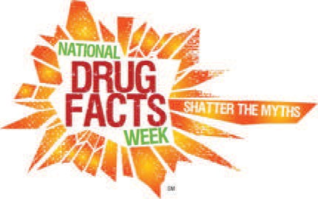*The video release sign-in sheet must be submitted along with the video. (see attached) Videos submitted without a release will NOT be eligible.

Questions? The Marion County Prevention Team is here it help! Email
mchdprevention@co.marion.or.us or call Kelly Martin at 503-981-2465

2017 NATIONAL DRUG FACTS WEEK "SHATTER THE MYTHS"
Contest Registration Form

Eligibility: The contest is open to residents of Marion County, Oregon, or groups affiliated with a Marion County School District. Participants may be up to 18 yrs old (those helping can be any age). Local schools or community groups or businesses that serve youth are eligible to participate. Individual entries are not allowed.

Contest registration must be received by Dec 30, 2016. Email completed form to mchdprevention@co.marion.or.us.

CONTACT INFORMATION

NAME OF GROUP/ ORGANIZATION:

NAME OF ADULT CONTACT: EMAIL ADDRESS:
PHONE NUMBER: STREET ADDRESS: CITY, STATE:
ZIP CODE:

NUMBER OF PARTICIPANTS:

BRIEF DESCRIPTION OF YOUR
PROJECT: (i.e., Holding an education forum, performing a song or dance, creating a PSA, etc.)

Questions? Email the Marion County Prevention Team at mchdprevention@co.marion.or.us or call Kelly Martin at 503-981-2465

