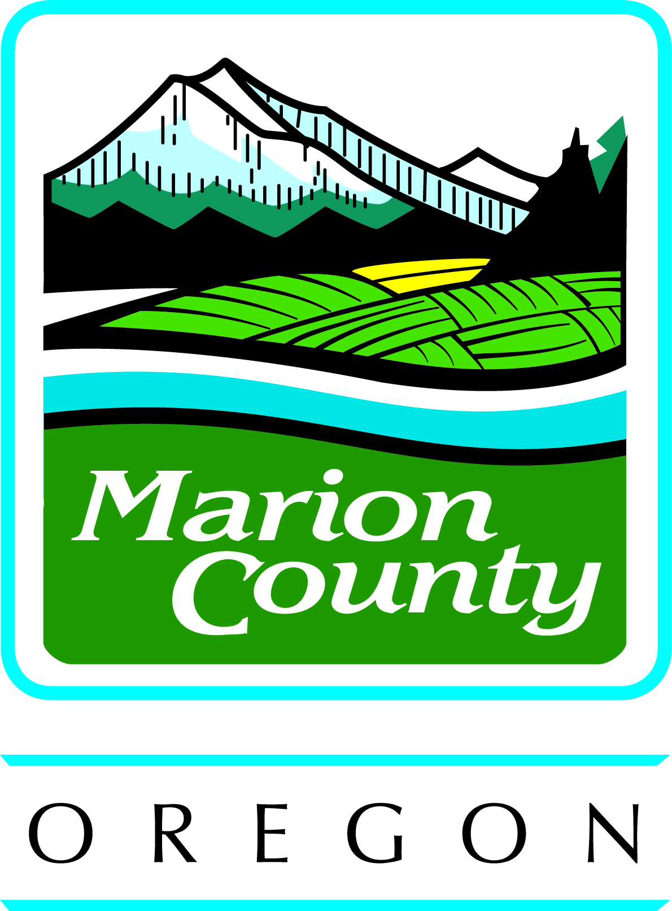
Marion County Health & Human Services

NOTICE OF PRIVACY PRACTICES

Acknowledgement of Receipt

PLEASE REVIEW THIS ACKNOWLEDGEMENT CAREFULLY AND THEN SIGN AND DATE BELOW.

The Notice of Privacy Practices tells you how Marion County Health & Human Services may collect, use or disclose health information about you and tells you about your privacy rights. Marion County Health & Human Services is required to offer you a Notice of Privacy Practices by federal law.

I, ________________________________________________, (client’s printed name)

have been offered a copy of the Marion County Health & Human Services’s Notice of Privacy Practices and have had a chance to ask questions about how my health information will be collected, used and disclosed and how to access my privacy rights.

_________________________________________ ___________________
Client’s Signature Date

_________________________________________ ___________________
Legal or Personal Representative of Client (if applicable) Relationship

This document is available in other languages and alternate formats that meet the
guidelines for the Americans with Disabilities Act (ADA).
Contact your Service Provider, or call the general number for the Health & Human Services at: Phone# 503-588-5357, or Fax# 503-364-6552.

Health & Human Services Staff: Please have this document completed and signed by the individual receiving the Notice of Privacy Practices.

Effective Date: June 1, 2013

